**ASSIGNMENT -4 (ADVANCED PROGRAMMING)**

**PISINI JOEL – 22BCS12519**

1. **Problem 1:** Longest Nice Substring
2. **Implementation/Code:**

class Solution {

public String longestNiceSubstring(String s) {

if (s.length() < 2) return "";

for (int i = 0; i < s.length(); i++) {

char ch = s.charAt(i);

if (s.contains(Character.toString(Character.toLowerCase(ch))) &&

s.contains(Character.toString(Character.toUpperCase(ch)))) {

continue;

}

String left = longestNiceSubstring(s.substring(0, i));

String right = longestNiceSubstring(s.substring(i + 1));

return left.length() >= right.length() ? left : right;

}

return s; }}

1. **Output:**

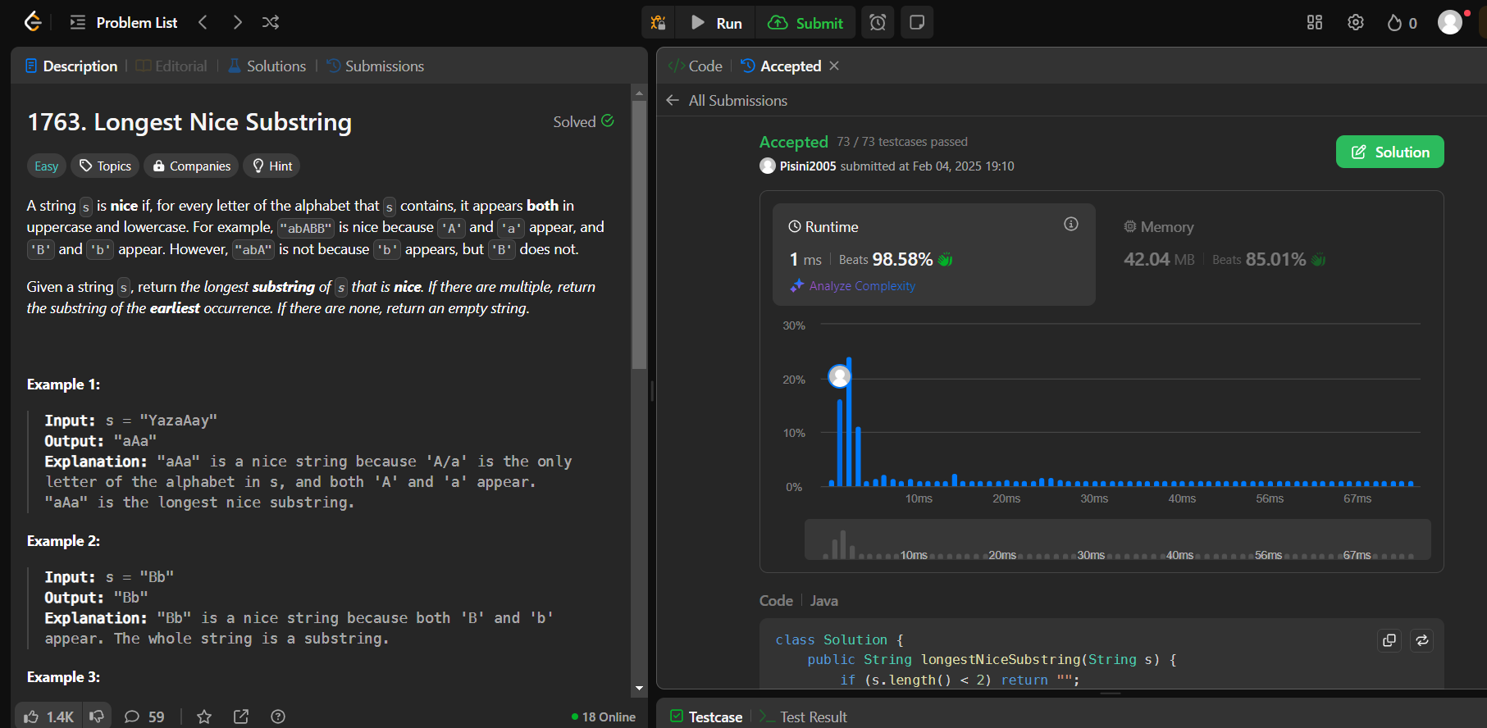

1. **Problem 2:** Reverse Bits
2. **Implementation/Code:**

public class Solution {

public int reverseBits(int n) {

int reversed = 0;

for (int i = 0; i < 32; i++) {

reversed = (reversed << 1) | (n & 1);

n >>>= 1;

}

return reversed;

}

}

1. **Output:**

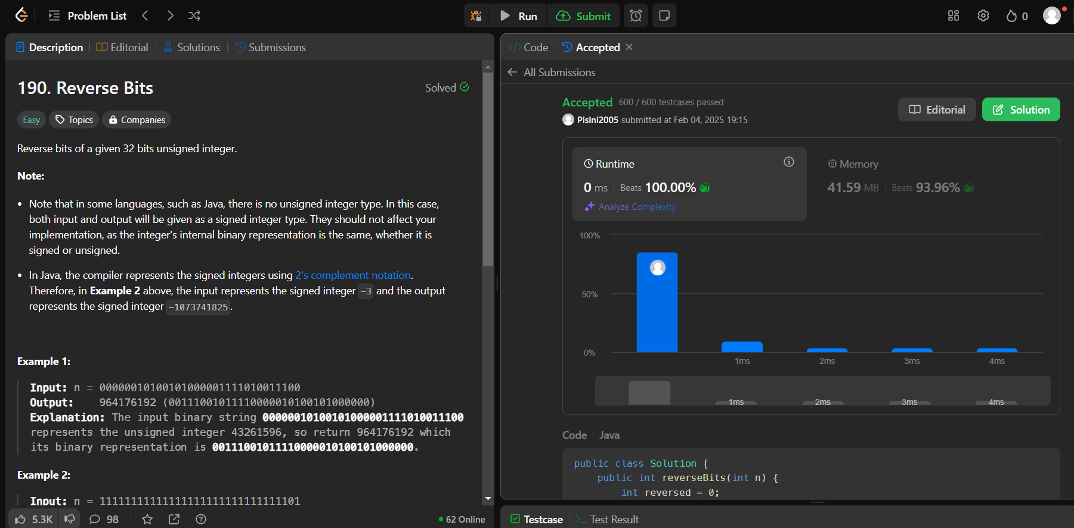

1. **Problem 3:** Number of 1 bits
2. **Implementation/code:**

public class Solution {

public int hammingWeight(int n) {

int count = 0;

while (n != 0) {

count += (n & 1);

n >>>= 1;

}

return count;

}

}

1. **Output:**

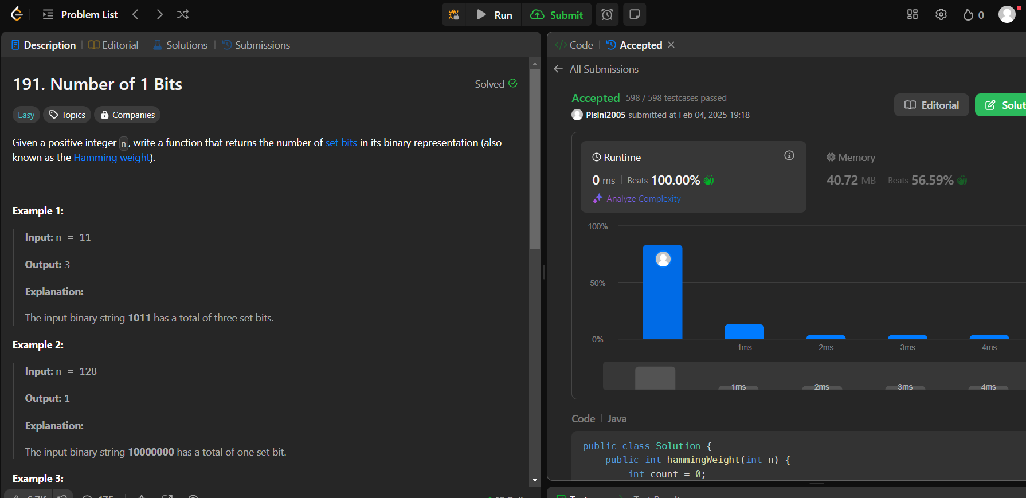

1. **Problem 4: Maximum Sub array**
2. **Implementation/code:**

public class Solution {

public int maxSubArray(int[] nums) {

int maxSum = nums[0], currentSum = 0;

for (int num : nums) {

currentSum = Math.max(num, currentSum + num);

maxSum = Math.max(maxSum, currentSum);

}

return maxSum;

}

}

1. **Output:**

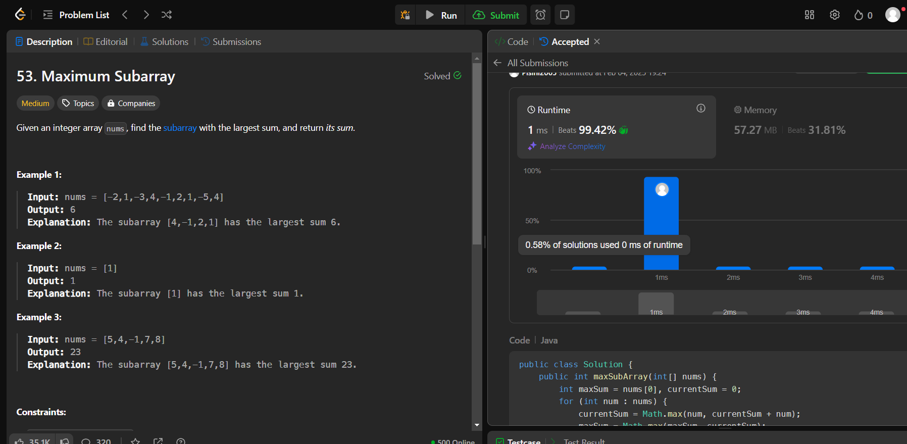

1. **Problem 5: Search a 2D Matrix II**
2. **Implementation/Code:**

public class Solution {

public boolean searchMatrix(int[][] matrix, int target) {

int rows = matrix.length, cols = matrix[0].length;

int row = 0, col = cols - 1;

while (row < rows && col >= 0) {

if (matrix[row][col] == target) {

return true;

} else if (matrix[row][col] < target) {

row++;

} else {

col--;

}

}

return false;

}}

1. **Output:**

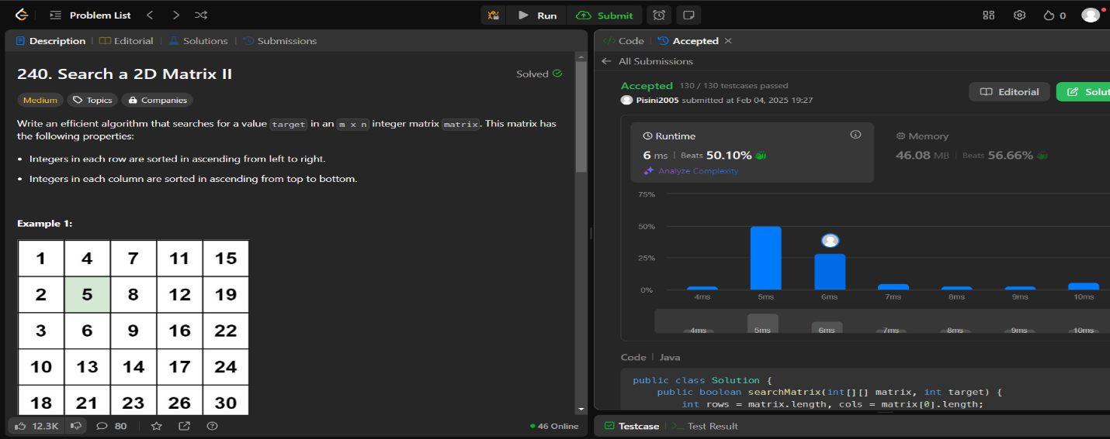

1. **Problem 6: Super Pow**
2. **Implementation/Code:**

public class Solution {

private static final int MOD = 1337;

private int pow(int a, int b) {

int res = 1;

a %= MOD;

for (int i = 0; i < b; i++) {

res = (res * a) % MOD; }

return res; }

public int superPow(int a, int[] b) {

int res = 1;

for (int i = b.length - 1; i >= 0; i--) {

res = (res * pow(a, b[i])) % MOD;

a = pow(a, 10);

}

return res; }}

1. **Output:**

